［Form Sheet 1］
Application Form for START2023
*START is an abbreviation for Study Assembly of Research at Touohgakkan

１. School Name (in English)
２：Teams
Title
[Scientific Field] Biology / Chemistry / Earth Science / Physics / Mathematics / Environment / Robotics / Architecture / Other ( )
 | Name | Age | Sex
1 |  |  | Female / male
2 |  |  | Female / male
3 |  |  | Female / male
4 |  |  | Female / male
Title
[Humanities] City Planning / Communication / Cultural Studies / Economics / History / Linguistics / Literature / Psychology / Politics / Other ( )
 | Name | Age | Sex
1 |  |  | Female / male
2 |  |  | Female / male
3 |  |  | Female / male
4 |  |  | Female / male
*Privacy Policy
All the participants are regarded as agreed to the conditions of the use of the private information written here and the recorded media only for the purpose of reports and advertisement of this assembly. | Check if agreed  □
【Teacher in charge】
Yamagata Prefectural Touohgakkan Junior and Senior High School
YAMAGUCHI Kazuhiko (Director of International Relationshiap in Department of Inquiry)
TEL：0237-53-1542 FAX：0237-53-1552
e-mail：syamaguchik@pref-yamagata.ed.jp

［Form Sheet 2］
Yamagata Prefectural TOUOHGAKKAN Junior and Senior High School
Address: 1-7-1 Chuo Minami, Higashine-shi, Yamagata-ken, 999-3730 JAPAN
Website: http://www.touohgakkan-jhh.ed.jp
Our school is located in Higashine City of Yamagata Prefecture, home to rich nature and delicious cherries which accessorizes the modernizing town. That is why we have a school mascot bird called “Saku-lucky.” Established in 2016 as the first Prefectural inter-disciplinary Junior and Senior high school in Yamagata Prefecture (from ages 12-18 years old), our school aims to foster students with aspirations, creative intellect and healthy mind and body. Designated as a Super Science High school as well as a member of UNESCO associated school, it has a peculiar program called Creating Future Project, in which students explore the fields they are interested in, including SDGs.
SAMPLE
[Scientific Field]
Title
Presenter (s)
Topic | □ Biology □ Chemistry □ Earth Science □ Physics □ Mathematics  □ Environmental Studies □ Robotics □ Architecture □ Other ( )
Abstract (NOT MORE THAN 300 WORDS)

[Humanities Field]
Title
Presenter (s)
Topic | □ City Planning □ Communication □ Cultural Studies □ Economics □ History  □ Linguistics □ Literature □ Psychology □ Politics □ Other ( )
Abstract (NOT MORE THAN 300 WORDS)

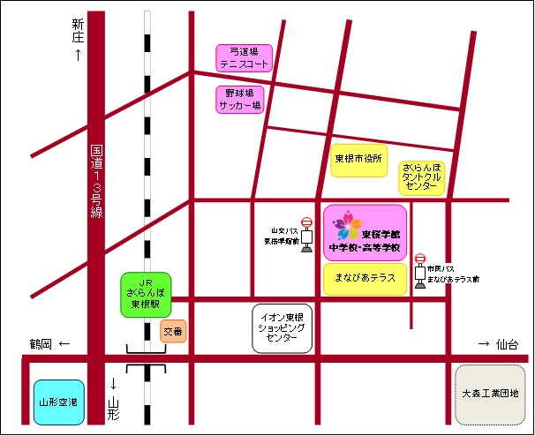
◎本校へのアクセス
（JRさくらんぼ東根駅から徒歩約10分）

